Product Summary

Specialty Shaped Stickers

- 30 eye-catching designs  - Drop in a photo or create your own layout in Photoshop or your preferred design software  - One set includes 20 Specialty Shaped Stickers  - Prices starting at $11.00 a set + GST | Bring “boutique” to your branding with our Specialty Shaped Stickers. Choose from 30 silhouettes to create signature stickers for matted prints, certificates of authenticity for the backside of wall displays, bag tags and closures, and fun favors for family portrait sessions.
Features and Pricing

Specialty Shaped Stickers

Features
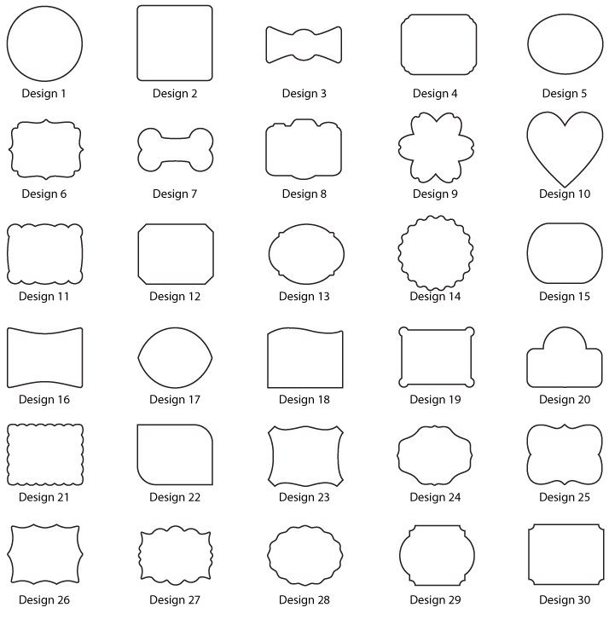
- Most designs are a general size of 2”x3.5” and the remaining designs are 2.5”x2.5”
- 4-color standard printing; 6-color upgrade for superior shading and skin tones
- Drop in a single image or create your own layout in Photoshop or your preferred design software

Specialty Shaped Stickers Pricing
One set includes 20 Specialty Shaped Stickers and price is reduced with a purchase of 6 or more sets of the same card

Specs and How to order

Specialty Shaped Stickers

Product Specs
Finished Size: 2" x 3.5", 2"x7", 4.25"x5.5"
Paper: Sticker with peal off back
Finishing Options: 6-Color Printing
Printing: Press
Resolution: minimum of 240 dpi
Safe Area/Margins: 0.25"
Accepted Files: jpg, 8 Bit, RGB

